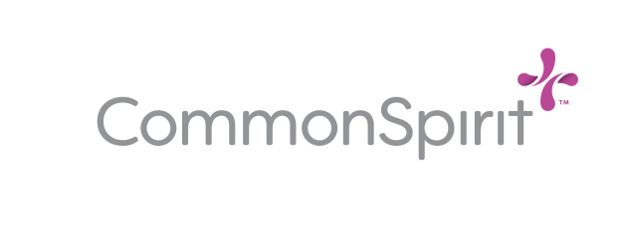
FAQs – PPE Reprocessing Program

- What it the CommonSpirit Health PPE Reprocessing program?
This is a program designed to sterilize masks and shields for reuse among our clinical teams. It is done in partnership with Medline Renewal, an Oregon-based medical supplier and medical device reprocessor.

- How does it work?
Each CommonSpirit location will receive Medline collection bins, where employees will be instructed to deposit their masks and shields. The masks and shields are then shipped to Medline Renewal, where they are sterilized through an Ethylene Oxide (EtO) process, which meets ISO and FDA recognized standards. Once complete, the masks are shields are returned to the CommonSpirit location. The entire process (including of shipping of items to Medline, sterilization and the return to the original location) takes seven days.

- Are n95 masks eligible for sterilization?
Medline is pending approval for reprocessing N95 masks. We are collecting them at this time in anticipation that they will receive approval in the very near future.

- When will the program start?
Immediately, though the program will be launched in phases through April 10. Please see the launch schedule below.

PPE Reprocessing Launch Schedule
DIVISION/FACILITY | PHASE | TIMELINE
Pacific Northwest | Phase 1 | April 1-3, 2020
Sacramento | Phase 1 | April 1-3, 2020
Texas | Phase 1 | April 1-3, 2020
Southwest | Phase 1 | April 1-3, 2020
Arizona | Phase 1 | April 1-3, 2020
Northern California | Phase 1 | April 1-3, 2020
St. Joseph’s Medical Center-Stockton | Phase 1 | April 1-3, 2020
Central Coast | Phase 2 | April 4-6, 2020
Kentucky | Phase 2 | April 4-6, 2020
Nebraska | Phase 2 | April 4-6, 2020
Iowa | Phase 2 | April 4-6, 2020
Tennessee | Phase 3 | April 4-6, 2020
Arkansas | Phase 3 | April 4-6, 2020
Ohio | Phase 3 | April 4-6, 2020
North Dakota | Phase 3 | April 4-6, 2020

- Which teams are coordinating the PPE Reprocessing program at our locations?
The Facility Leadership with SSRM and EVS in each of our facilities will be responsible for coordinating mask collection and reassignment for their sites. Patient Safety in the national office is working closely with them to ensure that they understand the program and know the guidelines, safety and compliance required for the program.

- Who do I contact for more details?
If you have questions, please reach out to Alex Aliberto, SSRM, System Director of Supply Chain Implementation, at Alexander.Aliberto@DignityHealth.org. Details about the logistics of the program will be provided to the site coordinators.

